**Documentation For Custom Project 6.4D**

**Name:** Thanh Tam Vo

**StudentID:** 103487596

This program will keep track the position of the International Space Station from NASA. By using OOP concepts such as inheritance, and polymorphism, the program will perform as a Console Application by taking user command from the terminal.

**The picture below will show how does the program work at the beginning**

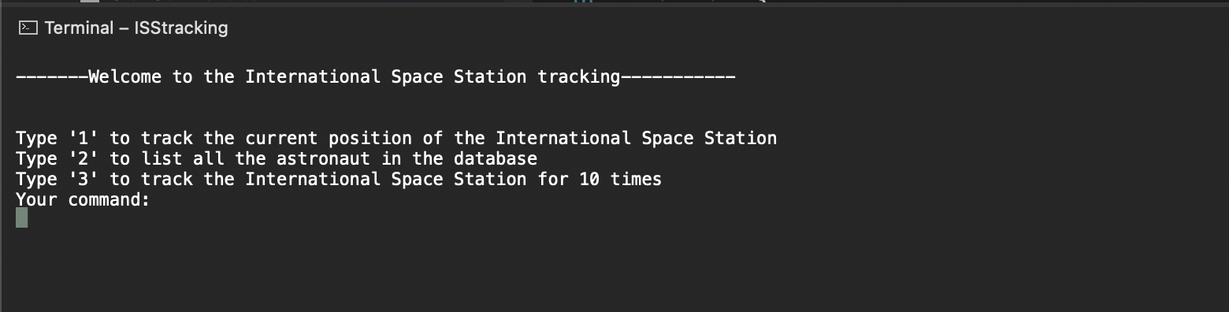

*Captured from my Mac on July 28th, 2022*

User will have 4 options:

1. Type ‘1’ to get the current position of the ISS
2. Type ‘2’ to get all the astronauts from the database
3. Type ‘3’ to keep track of the ISS position for 10 times
4. Otherwise, the program will return “Do not understand the command”

**When the user type ‘1’, the program will perform as picture below**

*Captured from my Mac on July 28th, 2022*

**When the user type ‘2’, the program will perform as picture below**

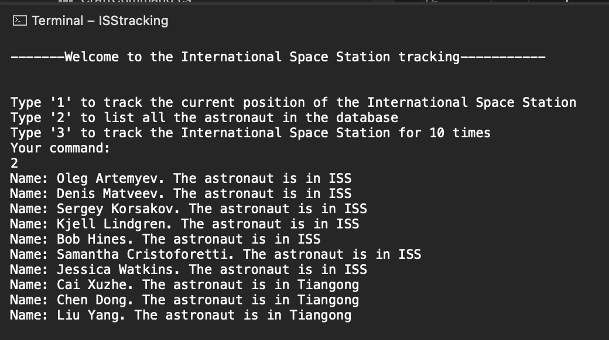s

*Captured from my Mac on July 28th, 2022*

**When the user type ‘3’, the program will perform as picture below**

*Captured from my Mac on July 28th, 2022*